You’re invited to Richmond Care Home to celebrate 25 years of innovative dementia care for women
Lesley McKaySeptember 20, 2025
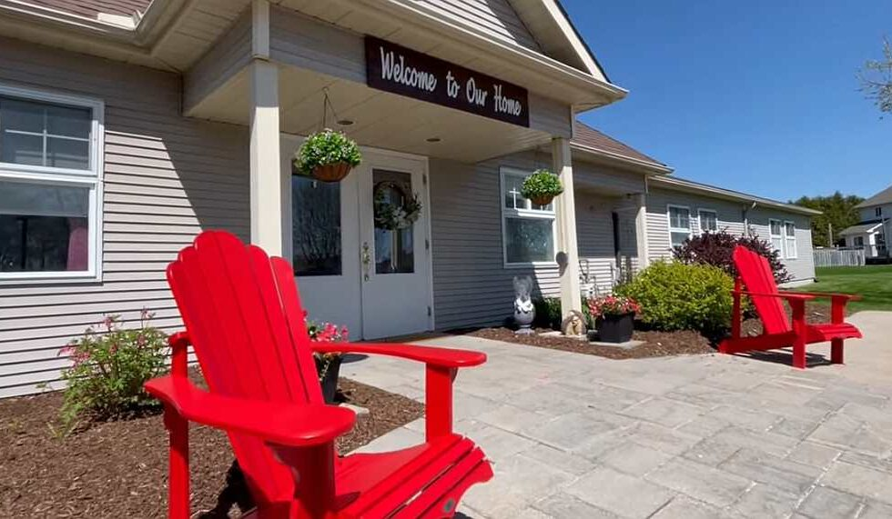
(The Richmond Care Home offers a unique model of care that is tailored to women living with dementia. This cozy, bungalow style retirement home truly feels like a home. Photos: Carefor Richmond Care Home)
For a quarter of a century, Richmond Care Home has stood apart as a model of what dementia care can look like when designed around the needs of residents rather than economies of scale. Built on research showing that small, home-like environments promote dignity, comfort, and independence, Richmond Care Home became one of the only such homes in Ontario that focused on women living with dementia.
The vision for Richmond Care Home began with John and Lillian Bosco, who opened its doors on September 5, 2000. John, a longtime social worker and dementia care manager, was inspired by international research showing how the impact of dementia can be lessened when the person with it lived in a retirement home that resembled an actual home rather than something more institutional. John and Lillian brought this idea to life in Richmond, creating a purpose-built home for just 16 women — small by design, and intentionally different from the larger retirement residences that were beginning to add “memory care wings” at the time.
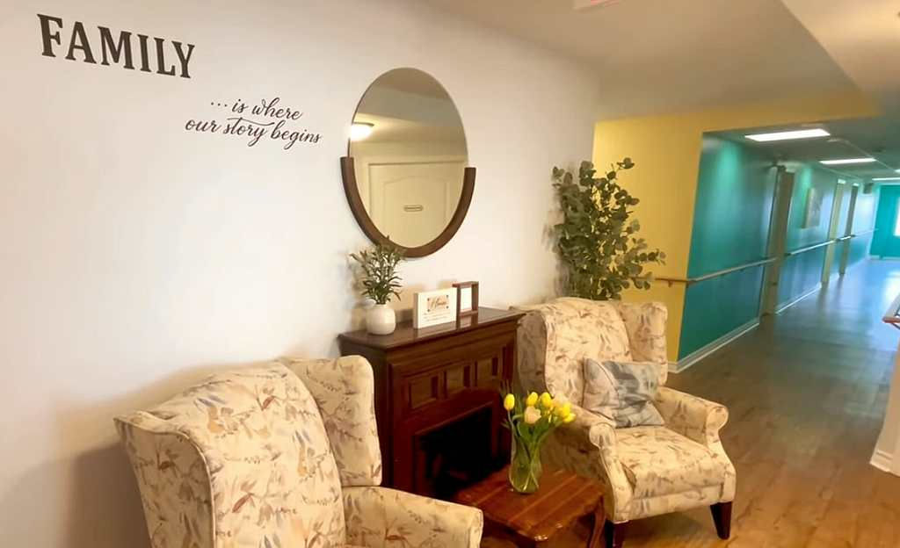
(A warm entrance greets family, visitors and residents where on the wall words define a core value of Richmond Care Home.)
With dementia rates rapidly increasing, memory care homes have become more common in our communities; unlike more institutional models, Richmond Care Home was built to feel like a real home. “The home is designed around common spaces that bring people together,” says John. Being on one floor with an open concept centred on the kitchen and access to a private garden, residents are able to transition from their homes to care more seamlessly.
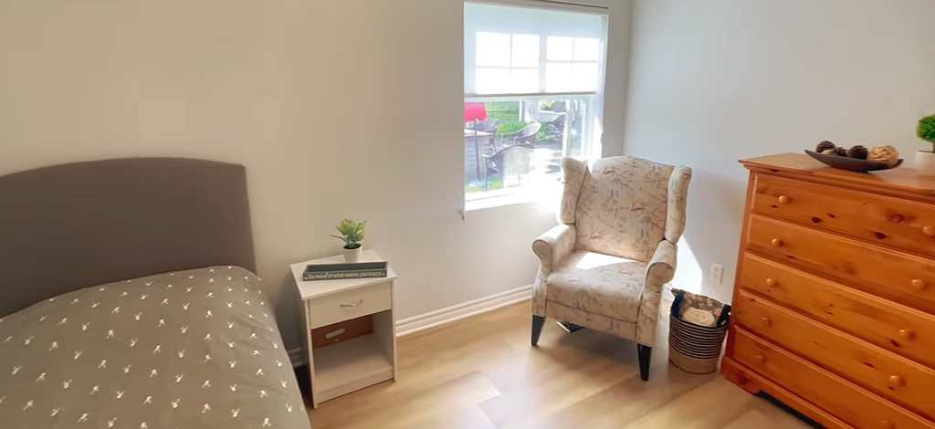(
One of the resident rooms that offers both comfort and simplicity for dementia residents.)
“Dementia is a growing issue among seniors, especially women. We know that when dealing with dementia care, having people live in an environment that resembles a home reduces stress and confusion and yields the best results for them,” said Steve Perry, President & CEO of Carefor.
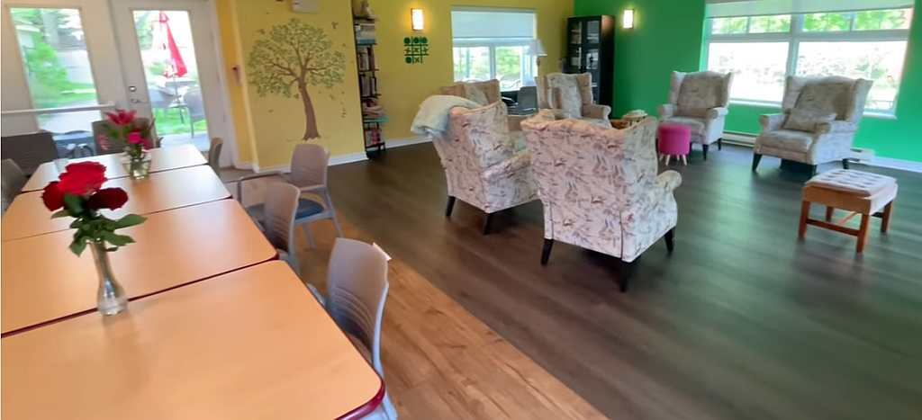(An open concept space allows for residents to meet and dine together under the watchful care of the Home’s team.)
Now operated by Carefor Health & Community Services, a not-for-profit with over 125 years of providing care in Ottawa and region, Richmond Care Home continues to embody the Boscos’ original vision. For 25 years it has provided families with a compassionate alternative to large-scale care, showing that intimacy, familiarity, and respect can transform the experience of living with dementia.
To mark this milestone, Carefor invites the community to join a 25th Anniversary Open House at Richmond Care Home on Sunday, September 28th from 1:00pm – 3:00pm. Guests will have the opportunity to tour the residence, meet staff and experience firsthand the environment that has made Richmond a trusted name in dementia care for a generation.
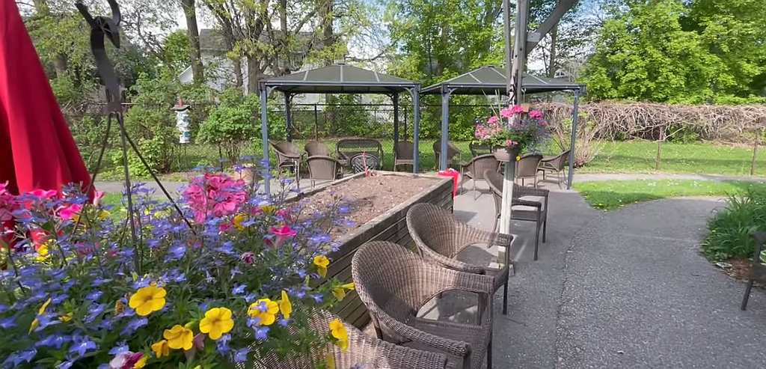(Residents can enjoy the private garden while experiencing a vital connection to nature that helps to improve mood, reduce anxiety, stimulate memories, and encourage physical activity.)
The Richmond Care Home is located at 27 Nixon Farm Drive in Richmond, Ontario. If you would like additional information, please send an email to: info@carefor.ca. Should you wish to attend the Open House, please RSVP at: www.carefor.ca/anniversary.
About Carefor:
Carefor Richmond Care Home is operated by Carefor Health & Community Services, a not-for-profit organization that has been caring for Ottawa’s most vulnerable since 1897. As the founding chapter of the Victorian Order of Nurses, Carefor continues to provide home and community support, nursing, and residential care throughout Eastern Ontario.

